Write as You Go Method
The information in brackets is formatted as headings and is where you would enter the information for your research project. To see the navigation panel, use Ctrl-F and click “Headings.” There is an example entry at the end of this document. Questions? Contact me at hello@heathermurphygen.com.

[Name of Person or Couple] (Heading 1)

Census (Heading 2)

[Census year, name of person or couple] (Heading 3)
Citation:
Image clip:
Abstract:
Analysis:

[Name of Head of Household]

[research goal, i. e. birth, death]
Citation:
Image Clip:
Abstract:
Analysis:

[Name of Spouse]

[research goal, i. e. birth, death]
Citation:
Image Clip:
Abstract:
Analysis:

[Name of Child]

[research goal, i. e. birth, death]
Citation:
Image Clip:
Abstract:
Analysis:

Future Research:

Research Summary:

Example:

Marriage, Fred Harry Fidele (1898) and Esther Johnnie (1901)
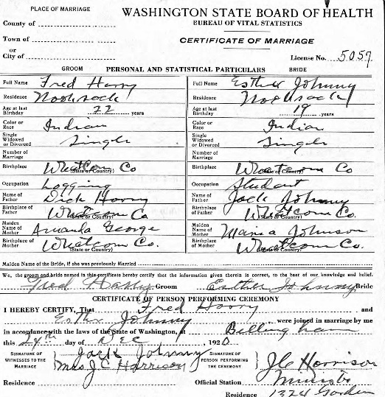
"Washington, Marriage Records, 1854-2013," database with images, Ancestry.com (www.ancestry.com : accessed 20 May 2019), entry for Fred Harry and Esther Johnny, no. 5057; citing Whatcom County Marriage Returns 1920 Sep-Dec.
Abstract:
Fred Harry and Esther Johnny married on 24 December 1920 at Bellingham, Whatcom, Washington. Fred was twenty-two years old and was born in Whatcom county to Dick Harry and Amanda George, who were both born in Whatcom county. Fred lived at Nooksack and worked in logging. Esther, age 19, was born in Whatcom county to Jack Johnny and Maria Johnson, who were both born in Whatcom county. She lived at Nooksack and was a student. J. C. Harrison, a minister, performed the marriage; Jack Johnny and Mrs. J. C. Harrison served as witnesses.
Analysis:
By their age at the time of marriage, Fred was born about 1898 and Esther was born about 1901, which is close to what other records said. This record named both sets of parents. Find them in the census with their parents.

